ASSIGNMENT – 6

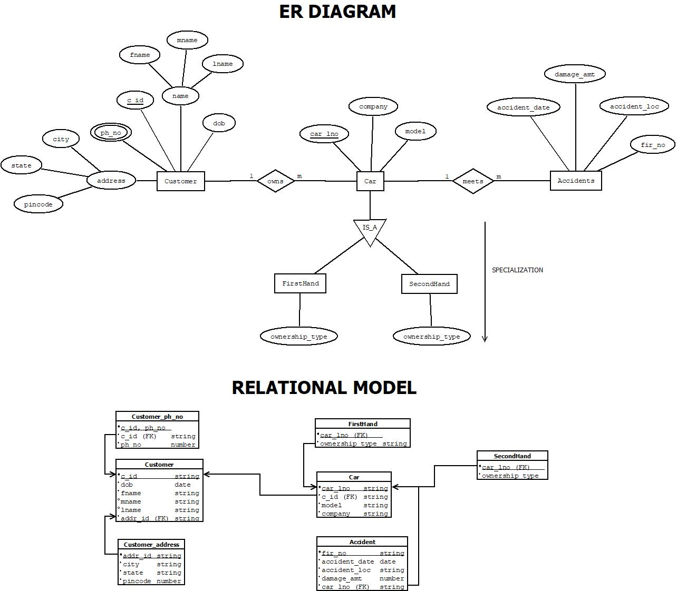

ASSUMPTIONS:-
- A Customer can own more than one car. This indicates a one-to-many relationship between the `CUSTOMER` entity and the `CAR` entity, established by the `CID` attribute in the `CAR` table, which serves as a foreign key referencing the `CID` attribute in the `CUSTOMER` table.
- A car can have multiple accidents. This indicates a one-to-many relationship between the `CAR` entity and the `ACCIDENT` entity, represented by the `LNO` attribute in the `ACCIDENT` table, which acts as a foreign key referencing the `LNO` attribute in the `CAR` table.
- A car has a classification of cars with two subtypes: FirstHand and SecondHnad Car. The ER diagram can represent this using the IS A relationship feature.
TABLE CREATE:-
create table Customer_address(
addr_id varchar2(5) check (addr_id like 'A%') primary key,
city varchar2(20) not null,
state varchar2(20) not null,
pincode number(6) not null
);
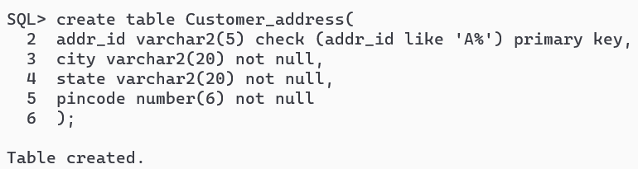
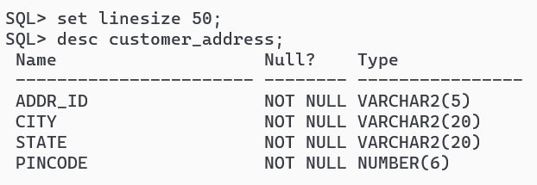
create table customer(
c_id varchar2(5) check (c_id like 'C%') primary key,
dob date not null,
fname varchar2(20) not null,
mname varchar2(20),
lname varchar2(20) not null,
addr_id varchar2(5) references Customer_address(addr_id) on delete cascade not null
);
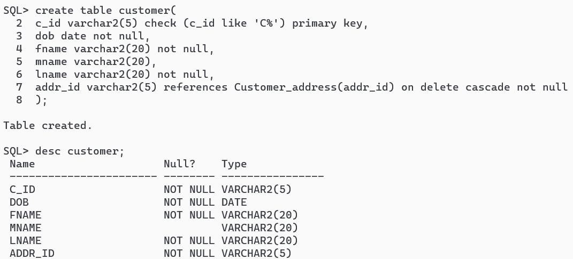
create table Customer_ph_no(
c_id varchar2(5) references Customer(c_id) on delete cascade not null,
ph_no number(10),
primary key (c_id, ph_no)
);
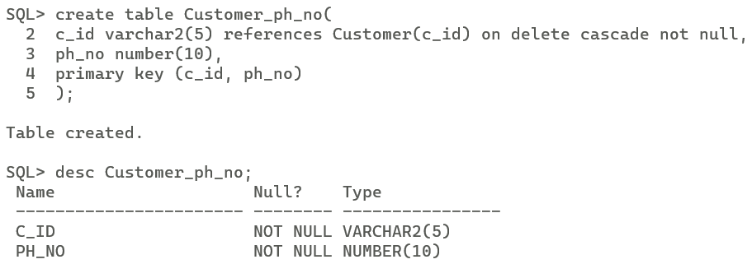
create table car(
car_lno varchar(20) primary key,
c_id varchar2(5) references Customer(c_id) on delete cascade not null,
company varchar2(20) not null,
model varchar2(20) not null
);
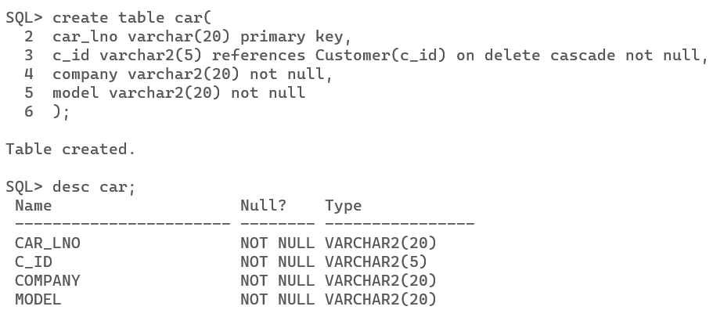
create table FirstHand(
car_lno varchar2(5) references car(car_lno) on delete cascade not null,
ownership_type varchar2(1) default 'F' check (ownership_type='F'),
primary key (car_lno)
);
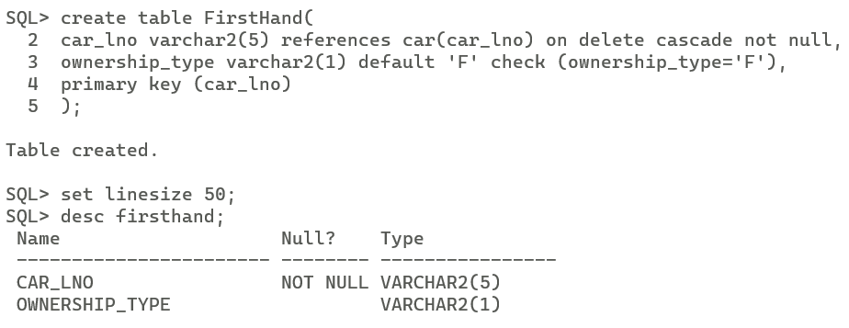
create table SecondHand(
car_lno varchar2(5) references car(car_lno) on delete cascade not null,
ownership_type varchar2(1) default 'F' check (ownership_type='S'),
primary key (car_lno)
);
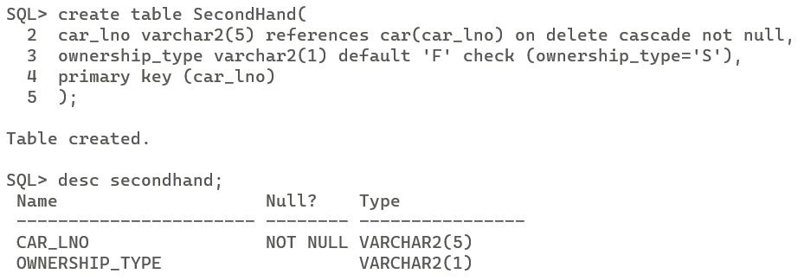
create table Accident(
fir_no varchar2(10) check (fir_no like 'FIR%') primary key,
car_lno varchar2(20) references car(car_lno) on delete cascade not null,
accident_date date not null,
accident_loc varchar2(20) not null,
damage_amt number(8, 2) not null
);
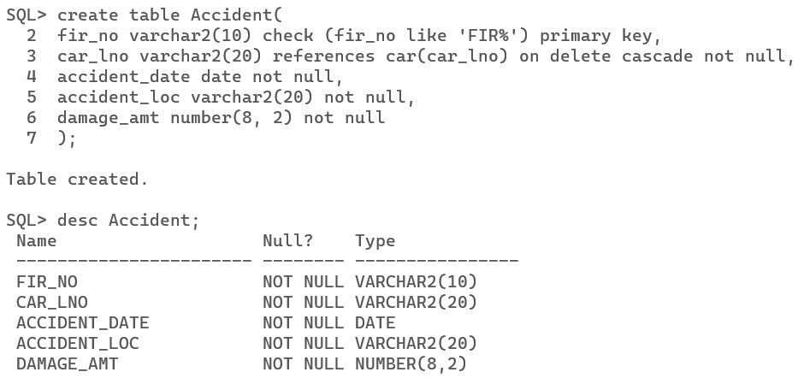
INSERT VALUES:-
insert all
into customer_address values ('A1', 'Kolkata', 'West Bengal', 700156)
into customer_address values ('A2', 'Krishnarampur', 'West Bengal', 712702)
into customer_address values ('A3', 'Chennai', 'Kerala', 700213)
into customer_address values ('A4', 'Mumbai', 'Maharastra', 700056)
into customer_address values ('A5', 'Bengaluru', 'Karnataka', 700256)
select 1 from dual;
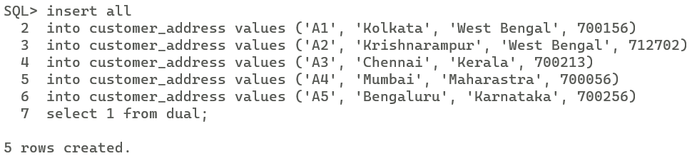
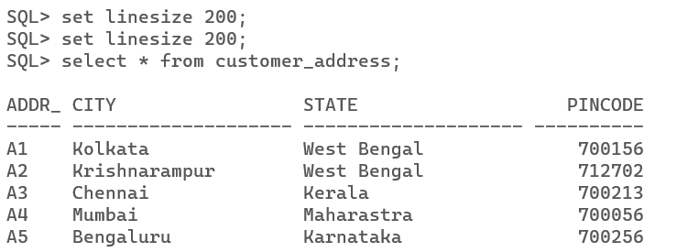

insert all
into customer values ('C1', to_date('17-03-2002', 'DD-MM-YYYY'), 'Abhirup', '', 'Bag', 'A2')
into customer values ('C2', to_date('15-06-2003', 'DD-MM-YYYY'), 'ABC', 'Roy', 'Choudhuri', 'A1')
into customer values ('C3', to_date('01-01-1945', 'DD-MM-YYYY'), 'Gokul', 'Chandra', 'Bag', 'A2')
into customer values ('C4', to_date('22-05-2004', 'DD-MM-YYYY'), 'Abaninda', 'Mukesh', 'Singh', 'A3')
into customer values ('C5', to_date('27-12-2002', 'DD-MM-YYYY'), 'XYZ', 'Chandra', 'Das', 'A2')
select 1 from dual;
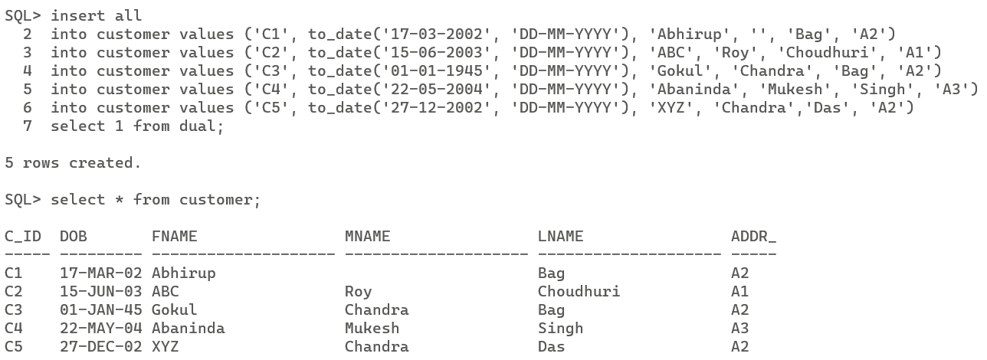
insert all
into customer_ph_no values ('C1', 9339316128)
into customer_ph_no values ('C1', 6296885021)
into customer_ph_no values ('C2', 7477516708)
into customer_ph_no values ('C3', 9785473428)
into customer_ph_no values ('C4', 9339316128)
into customer_ph_no values ('C4', 9002168757)
into customer_ph_no values ('C5', 8972502145)
select 1 from dual;
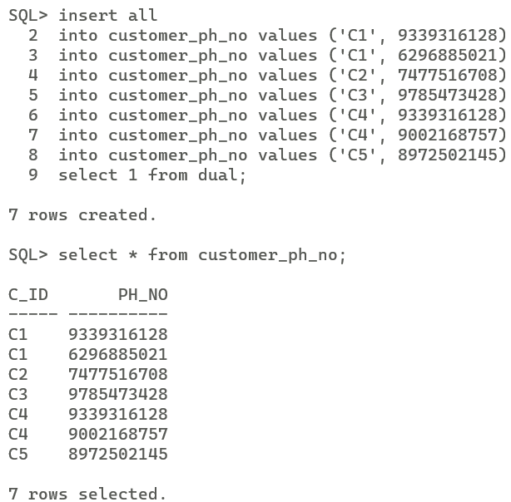
INSERT ALL
INTO car VALUES ('WB01AB1234', 'C1', 'Maruti Suzuki', 'Swift')
INTO car VALUES ('WB01CD5678', 'C1', 'Hyundai', 'Creta')
INTO car VALUES ('MH12XY9101', 'C2', 'Mahindra', 'Scorpio')
INTO car VALUES ('MH14LM2345', 'C2', 'Toyota', 'Innova')
INTO car VALUES ('KA05GH6789', 'C3', 'Tata', 'Nexon')
INTO car VALUES ('TN07JK3456', 'C4', 'Mahindra', 'XUV700')
INTO car VALUES ('TN07JK3489', 'C5', 'Mahindra', 'Scorpio')
INTO car VALUES ('AIBPC2010', 'C5', 'Toyota', 'Innova')
SELECT 1 FROM DUAL;
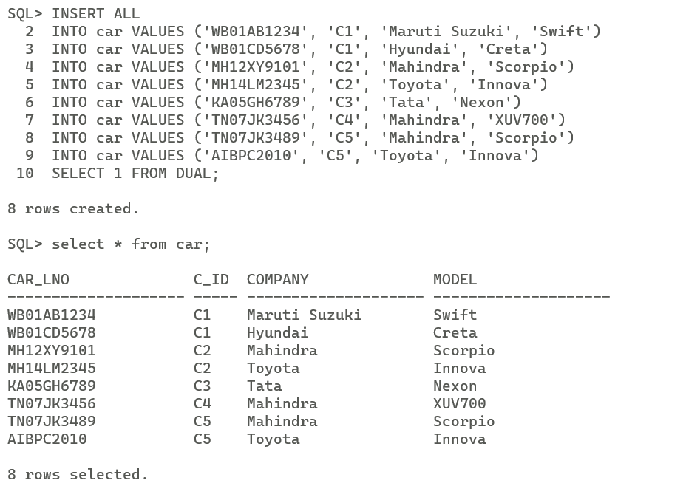
insert all
into FirstHand values ('WB01AB1234', 'F')
into FirstHand values ('MH14LM2345', 'F')
into FirstHand values ('KA05GH6789', 'F')
into FirstHand values ('TN07JK3489', 'F')
select 1 from dual;
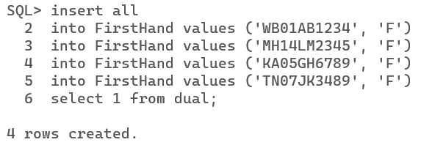
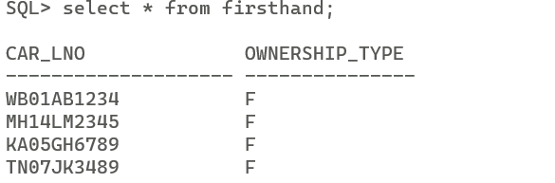
insert all
into SecondHand values ('WB01CD5678', 'S')
into SecondHand values ('MH12XY9101', 'S')
into SecondHand values ('TN07JK3456', 'S')
into SecondHand values ('TN07JK6296', 'S')
select 1 from dual;
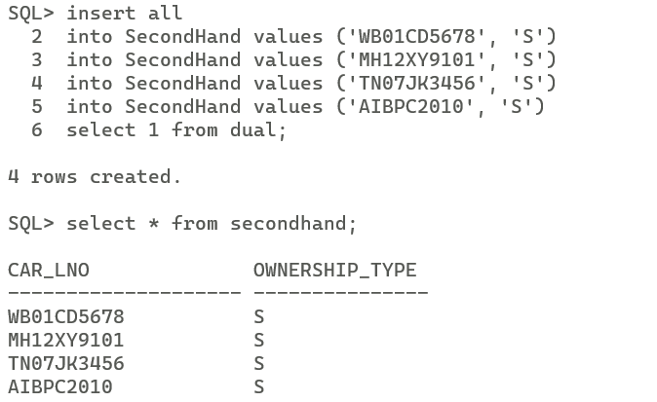
insert all
into accident values ('FIR1', 'WB01AB1234', to_date('12-03-2010', 'DD-MM-YYYY'), 'Bidhannagar', '30000')
into accident values ('FIR2', 'MH14LM2345', to_date('15-11-2024', 'DD-MM-YYYY'), 'SectorV', '10000')
into accident values ('FIR3', 'KA05GH6789', to_date('01-02-2025', 'DD-MM-YYYY'), 'SectorV', '15000')
into accident values ('FIR4', 'TN07JK3489', to_date('15-02-2025', 'DD-MM-YYYY'), 'Navi Mumbai', '19000')
into accident values ('FIR5', 'WB01CD5678', to_date('16-09-2010', 'DD-MM-YYYY'), 'Navi Mumbai', '8000')
into accident values ('FIR6', 'MH12XY9101', to_date('26-11-2019', 'DD-MM-YYYY'), 'Delhi', '23476.67')
into accident values ('FIR7', 'TN07JK3456', to_date('20-10-2017', 'DD-MM-YYYY'), 'Kerala', '21100.50')
into accident values ('FIR271', 'AIBPC2010', to_date('24-04-2023', 'DD-MM-YYYY'), 'Ladakh', '50000.50')
select 1 from dual;
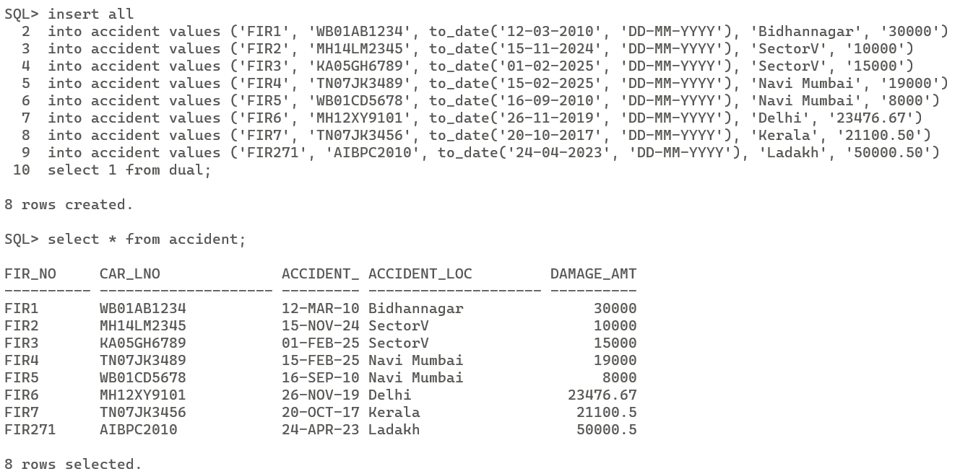

QUERIES:-
1. Find the total number of people who owned cars that were involved in accidents in 2010.
select count(*) as number_of_people from
customer join car on customer.c_id = car.c_id
join accident on car.car_lno = accident.car_lno
where extract(year from accident.accident_date) = 2010;
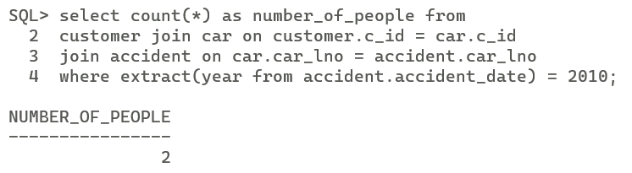
2. Find the number of accidents in which the cars belonging to “XYZ” were involved.
select count(*) as number_of_accidents from
customer join car on customer.c_id = car.c_id
join accident on car.car_lno = accident.car_lno
where customer.fname = 'XYZ';
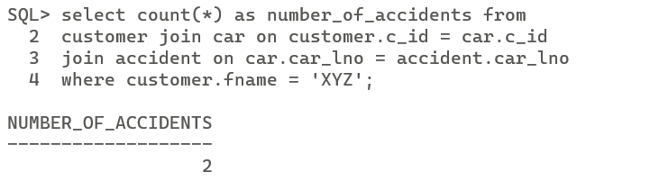
3. Add a new accident to the database; assume any values for required attributes.
insert into accident
values ('FIR272', 'TN07JK3456', to_date('17-03-2025', 'DD-MM-YYYY'), 'Ladakh', '5000.50');
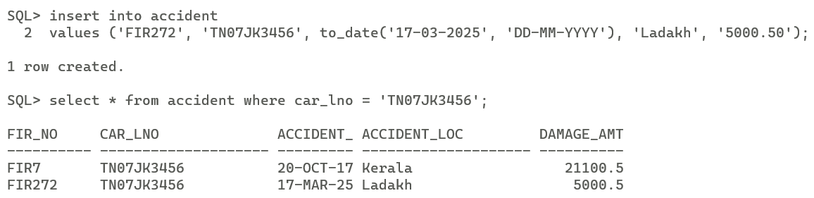
4. Delete the model ‘Scorpio belonging to “ABC”.
delete from car where c_id in ( select c_id from customer where fname = 'ABC') and model = 'Scorpio';
5. Update the damage amount for the car with license number “AIBPC2010” in the accident with report number “FIR271” to Rs. 5000.
update accident set damage_amt = 5000 where car_lno = 'AIBPC2010' and fir_no = 'FIR271';
